Pasture preservation: Leverage these simple treatments
Throughout the season, troublesome weeds and brush will threaten your pasture, which will ultimately impact your bottom line. Many brush and broadleaf weeds tend to emerge and multiply on grazing acres. In addition to impacting return on investment, this can deter your cattle and reduce pasture utilization.

The good news: A simple tank mix and a similarly easy high-volume foliar treatment method can help prevent, and stop, these worrisome species. With summer upon us, now is the ideal time to preserve your pasture. Be sure to take into account the following solutions:
- Remedy® Ultra herbicide is an outstanding, long-lasting option against most brush.
- Adding DuraCor® herbicide to the tank mix sharpens activity on certain woody species and adds broad-spectrum broadleaf weed control.

So, armed with these two herbicides, load up your backpack sprayer, ATV rig or large, tractor-powered unit and head to the pasture.

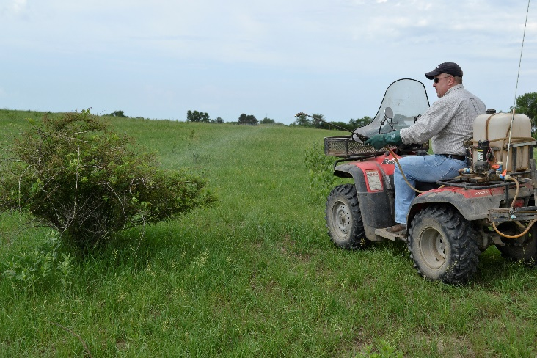
This high-volume foliar method both easily and economically provides you with what you need to stop headaches like volunteer trees, thorny brush like multiflora rose and other species before they become larger (and more-expensive) problems. One callout: Mature brush stands usually require an aerial application to achieve adequate coverage for success.

Spray the leaves
You’ll need to prepare a tank mix of Remedy Ultra plus DuraCor in water. (The accompanying table provides mixing ratios for common sprayer sizes.) Then spray the leaves of target plants until thoroughly wet. Complete coverage is crucial for success, so make sure target plants aren’t too tall.

This herbicide combination provides broad-spectrum control of many woody plants, including hedge (Osage orange, bois d’arc), multiflora rose, cottonwood, locust, sumac, Virginia creeper, hackberry and hawthorn. And it won’t damage desirable grasses. Plus, this mix is effective against most broadleaf weeds — perfect for preserving valuable fence lines and general pasture cleanup where weeds and brush are present.

Finally, when reclaiming tracts overrun by large trees, it’s important to work closely with your aerial applicator or local Corteva Agriscience Range & Pasture Specialist. These experts can help identify and record species present and develop a prescription program tailored to your needs. Once restored, your land — and your bottom dollar — will benefit from an effective pasture maintenance program.

Spot-treatment Mixing Guide — Broad-spectrum Brush and Weed Control (Water Carrier)
Sprayer Size | DuraCor® Herbicide (0.31% v/v) | Remedy® Ultra Herbicide (0.5% v/v) | Surfactant  (Species-dependent)
 |  |  | 0.25% NIS OR 1% MSO
3 gal. | 1.2 fl. oz. | 2 fl. oz. | 1 fl. oz. | 4 fl. oz.
5 gal. | 2 fl. oz. | 3.2 fl. oz. | 1.6 fl. oz. | 6.4 fl. oz.
10 gal. | 4 fl. oz. | 6.4 fl. oz. | 3.2 fl. oz. | 12.8 fl. oz.
25 gal. | 10 fl. oz. | 1 pt. | 8 fl. oz. | 1 qt.
50 gal. | 20 fl. oz. | 1 qt. | 1 pt. | 2 qt.

Notes: NIS = nonionic surfactant; MSO = methylated seed oil. Spot treatments may be applied at an equivalent broadcast rate of up to 40 fluid ounces of DuraCor® herbicide per acre per annual growing season. However, not more than 50% of an acre may be treated at that rate.

-end-

Contact:
Erik Johnson
Bader Rutter
ejohnson@bader-rutter.com
262-993-9837

® Trademarks of Corteva Agriscience and its affiliated companies. Under normal field conditions, DuraCor® is nonvolatile. DuraCor has no grazing or haying restrictions for any class of livestock, including lactating dairy cows, horses (including lactating mares) and meat animals prior to slaughter. Label precautions apply to forage treated with DuraCor and to manure and urine from animals that have consumed treated forage. DuraCor is not registered for sale or use in all states. Contact your state pesticide regulatory agency to determine if a product is registered for sale or use in your state. Consult the label for full details. State restrictions on the sale and use of Remedy® Ultra apply. Consult the label before purchase or use for full details. Always read and follow label directions.

