Aid Recovery, Boost Spring Grazing with Fall Weed and Feed

Fall is a critical time for grazing lands, whether producers are managing through drought, working to restore balance in pastures or simply setting up their grasses for success in the next grazing season.

This is the season for repair — at least when it comes to pastures, says Sam Ingram, Corteva Agriscience Range & Pasture field scientist.

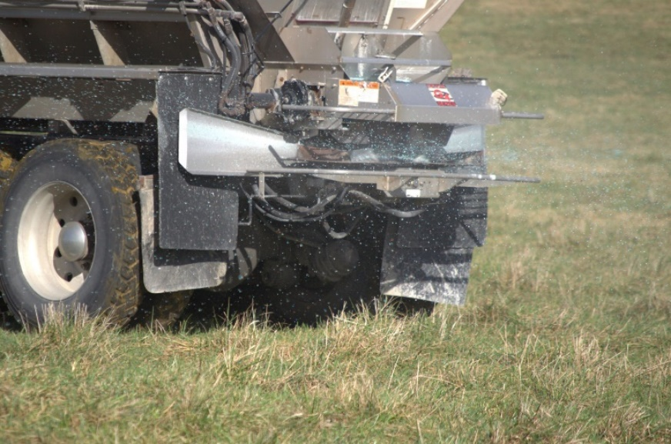
“During the spring, we control weeds so they’re out of the way of grass production,” Ingram explains. “In the fall, we’re looking to repair the stand — especially in cool-season grasses.” During fall, cool-season grasses are growing new tillers and rebuilding root systems that will carry them through the next growing season.

“Think of it as maintenance season for grasses. Remove the competition from those undesirable weeds, and we can go into the next season with dense, highly competitive grass stands that will hold back weeds,” Ingram says.

Take the next step; combine steps

Cool-season grasses recover faster and more completely with proper fertility, and fall is an excellent time to provide those nutrients. UltiGraz℠ Pasture Weed & Feed lets producers control weeds and fertilize pastures in a single pass.

“It’s like an athlete after a big event,” Ingram says. “Without proper nutrition, recovery takes longer. Our forage grasses work hard all season. We need to feed them so they’re ready come spring.”

UltiGraz is an efficient way to accomplish that. It’s convenient, saving time and expense.

“UltiGraz is available only through authorized retailers,” Ingram says. “They’re trained on the product. And fall is a good time, because many applicators have more time and fertilizing in fall often costs less than during the spring.”

Learn more and find nearby authorized retailers at UltiGraz.com.

-end-

Photo Caption:

Removing weed competition and meeting fertility needs will help forage grasses recover following a stressful grazing season. This fall, producers can accomplish both tasks in a single pass, helping pastures get off to a faster start next spring.

Contact:
Erik Johnson
Bader Rutter
262-993-9837
ejohnson@bader-rutter.com

™ ® Trademarks and service marks of Corteva Agriscience and its affiliated companies. UltiGraz℠ with fertilizer is available for use with specific herbicides in the states of AL, AR, CO, FL, GA, HI, IA, ID, KS, KY, LA, MN, MO, MS, MT, NC, ND, NE, NV, OK, OR, SC, SD, TN, TX, UT, VA, WA, WI, WV and WY. Contact your state pesticide regulatory agency to determine if a product is registered for sale or use in your state. Always read and follow label directions. © 2023 Corteva.

