Controlling briars in summer pastures

Preventing briar patches from encroaching on pastures helps maximize your lowest-cost feed source — grass. But the most effective control of persistent briars, such as blackberry or dewberry, comes from timely herbicide applications in early summer, late summer or fall.

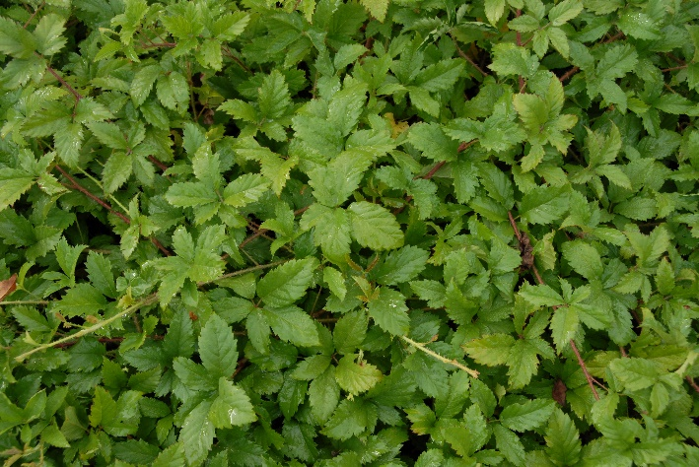
Hard-to-control prickly shrubs can quickly close in on grazing areas. And while dewberry is much more difficult to control than blackberry, both types of briars present problems in pastures and hayfields.

From a distance, dewberry and blackberry can be confused, but they are relatively easy to distinguish upon close examination. Dewberry, or trailing blackberry, exhibits low, vinelike trailing growth, rarely growing higher than 2 feet tall. Whereas blackberry growth rambles upright, which can form impenetrable thickets that are often 4 to 6 feet tall.

Early summer for blackberry
Blackberry is most susceptible to control after fruit drop in mid- to late summer or again in the fall. You will have the best results targeting blackberry when it’s emerged and actively growing to ensure maximum herbicide uptake and root translocation.

“The plant is loading energy from the leaves into the root system at these times,” says Scott Flynn, Ph.D., zonal biology leader for Corteva Agriscience. “That’s the peak time for herbicide to enter the leaf and immediately be transported to the roots, where it is most effective.”

He recommends applying herbicides after fruit drop. “The maturity of the foliage makes a difference,” Flynn says. “If blackberry has been mowed, make sure it has at least a full summer’s growth before you spray.”

When timing is right, broadcast-spraying 16 fluid ounces of DuraCor® herbicide plus 16 fluid ounces of PastureGard® HL herbicide per acre is highly effective at controlling blackberry. A follow-up application a year later may be needed using the same ratio.

Late summer for dewberry
Although the flowers produced by both may look similar, dewberry tends to flower about one to two months earlier in the spring than blackberry. Dewberry can be controlled with 3.3 ounces of Chaparral™ herbicide per acre. But for best control of dewberry, hold application off until after fruit has dropped in late summer.

Frequently cut hayfields are the most difficult areas to get good control of briars, particularly dewberry. Avoid cutting treated dewberry or blackberry until the stems are completely dry and brittle. This may mean cutting around treated patches for one to two months.

If you weren’t able to treat briars in the summer, fall is also an excellent time to control blackberry and dewberry. But to get sufficient regrowth for effective herbicide application in the fall, do not mow briar patches during the summer.

Persistence pays
Flynn adds mowing pastures or cutting hay alone will not control dewberry or blackberry. “It may temporarily reduce the size or top growth of these weeds, but they will rapidly recover,” he says. “But mowing can remove old, dead stems and leaves that interfere with herbicide deposition. Eliminating that can make herbicide application easier to reach the new, uniform regrowth.”

If all pastures cannot be covered in the prime application windows, producers can mow in the summer the first year and then spray the following summer when shoots have regrown. And for dense blackberry or blackberry that has been shredded, Flynn typically recommends a second-year follow-up application for full control.

Sidebar:

For maximum briar control, avoid these common pitfalls:
- Spraying blackberry or dewberry under drought-stressed conditions.
- Mowing pastures or cutting hayfields immediately followed by spraying (before there is sufficient regrowth to receive spray).
- Shredding pastures after spraying (before treated stems are “crispy” all the way to the ground).

-end-

Contact:
Amanda Powell
Bader Rutter
apowell@bader-rutter.com
770-356-1480

™ ® Trademarks of Corteva Agriscience and its affiliated companies. Under normal field conditions, DuraCor® is nonvolatile. Chaparral™ and DuraCor have no grazing or haying restrictions for any class of livestock, including lactating dairy cows, horses (including lactating mares) and meat animals prior to slaughter. Label precautions apply to forage treated with Chaparral or DuraCor and to manure and urine from animals that have consumed treated forage. Chaparral and DuraCor are not registered for sale or use in all states. Contact your state pesticide regulatory agency to determine if a product is registered for sale or use in your state. Consult the label for full details. Always read and follow label directions.

