Maximizing existing acres pencils out for Kansas producer

Located between two growing communities hungry for country living, a pasture-based cow-calf operation seems unlikely, if not impossible. But Phil Perry and his wife, Rhonda, found success on their Oskaloosa, Kansas, ranch through patience and caring for the land.

“We grow a lot of houses out here,” Phil Perry says of the area between Lawrence and Topeka, Kansas, about 45 minutes west of Kansas City, Kansas. “That makes it a challenge to expand our operation. So we make sure we get the most from the land we have.”

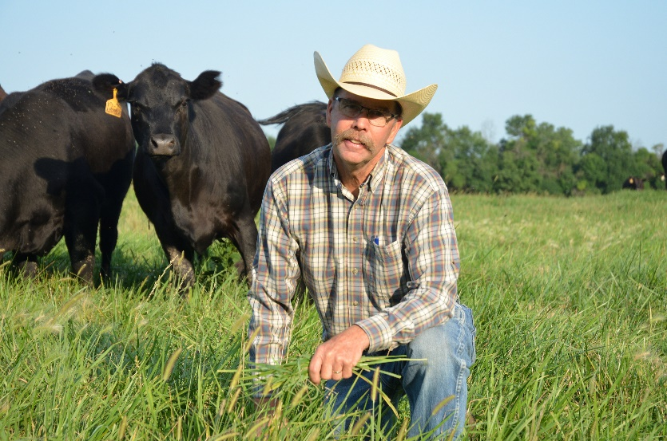
The Perrys ranch on 300 deeded acres and 2,500 acres of rented grazing land and hay ground. They maintain about 500 females and annually retain at least 100 heifers. They’re active in the cattle industry too. Phil Perry immediate past president of the Kansas Livestock Association and serves as the state’s representative on the Cattlemen’s Beef Board.

Pastures range from 20 acres to a half-section, or larger. Regardless, each parcel gets the same level of care — sound grazing management, plus weed control and fertilizer as needed.

“We’ve been fortunate to grow by adding and keeping leased ground. By working closely with our landlords and demonstrating we’re good caretakers, we’ve held some leases nearly 30 years,” Perry says.

They’ve also grown by increasing stocking rates without harming the long-term viability of the land resource. That often starts with weed control.

“If a pasture is 10% weeds and I take out those weeds, that gives me 10% more pasture,” Perry explains. “If I can run a couple of extra cows on 80 acres, or four cows on a half-section, I’m improving per-acre productivity. By spreading labor, fencing costs and other expenses — even bull power — across more animals, I feel like it’s money well spent.”

Letting cows do the work
Perry says they aim to graze 10 months while keeping cows on pasture year-round. That means going easy on stocking rates and stockpiling as much forage as possible. The goal: hold off on hay feeding until Christmas. He says year-round pasturing keeps cows in a better, more-natural environment.

Staying nimble helps too. Perry holds close the adage: Well-summered, half-wintered.

“If we notice grass running short and the cows’ condition falling off, we’ll wean pretty early — the first or second week of September on a March-born calf ¬— if conditions dictate,” he explains. “She’ll be a lot easier to winter.”

With so much of their success hinging on grass and maintaining a stocking rate of about 4 acres per cow, Perry says, they focus resources on proper fertility and weed control — and now, combining the two in a single application with UltiGraz℠ Pasture Weed & Feed.

Through the years, the Perrys had occasionally combined GrazonNext® HL herbicide with liquid nitrogen. But when their applicator began offering dry fertilizer impregnated with herbicide, they made the switch.

“We prefer dry fertilizer,” Perry says. “We can blend according to what our pastures need. And we can control weeds in areas such as in fence lines you can’t reach with spray booms. Plus, there’s no drift.” That’s especially important as vineyards and truck farms grow in popularity.

Lessons learned
Although the Perrys don’t skimp on care for their pastures or hayfields, 2022 fertilizer prices forced a tough decision, and they chose fertilizer over weed control.

“To achieve the coverage needed to provide adequate weed control, we needed to apply at least 200 pounds of dry fertilizer per acre, so we decided to cut our fertilizer rate on the pastures and go without herbicide,” Perry explains. Per usual, he monitored pastures and kept detailed notes through the grazing season. Those notes included a lot of jottings about weeds.

“Let’s just say, we’ll be putting a pencil to it this spring,” he says. “We’ll figure out a way to make sure we include weed control with our dry fertilizer. It’s money well spent.”

Investing in a preventive approach to brush control pays big dividends too, Perry adds. The area receives nearly 35 inches annual rainfall. Woody plants, including sericea lespedeza and volunteer trees, can quickly eat up grazing space. Some pastures have required broadcast applications of Remedy® Ultra herbicide. Generally, though, Perry maintains pastures as he evaluates them, crisscrossing them on his utility terrain vehicle (UTV).

“I ride pastures with a UTV during the summer, taking notes and checking on the cattle,” he says. “That UTV always has a spray tank in the back loaded with Remedy Ultra, so I can treat any emerging saplings and stay ahead of potential trouble.”

The time and effort are worth it, Perry says.

“We’ve been very fortunate to have landlords who understand and appreciate what we’re doing to care for their land,” he adds. “They’ve been very good to us, and that’s helped us continue to advance our cattle operation.”

-end-

Photo Caption:

Kansas cattle producer Phil Perry found out the hard way the value weed control brings to pasture fertilizer programs.

Contact:
Erik Johnson
Bader Rutter
262-993-9837
ejohnson@bader-rutter.com

® ℠ Trademarks and service marks of Corteva Agriscience and its affiliated companies. GrazonNext® HL has no grazing or haying restrictions for any class of livestock, including lactating dairy cows, horses (including lactating mares) and meat animals prior to slaughter. Label precautions apply to forage treated with GrazonNext HL and to manure and urine from animals that have consumed treated forage. Consult the label for full details. GrazonNext HL is not registered for sale or use in all states. UltiGraz℠ with fertilizer is available for use with specific herbicides in the states of AL, AR, FL, GA, IA, KS, KY, LA, MO, MS, NC, ND, NE, OK, OR, SC, SD, TN, TX, VA, WA and WV. Contact your state pesticide regulatory agency to determine if a product is registered for sale or use in your state. State restrictions on the sale and use of Remedy® Ultra apply. Consult the label before purchase or use for full details. Always read and follow label directions.

