Rebuilding the Cattle Herd Starts With Rebuilding Pastures
Corteva Agriscience Recommends 4 Steps to Help Get Your Grazing Land in Shape

INDIANAPOLIS, Feb. 28, 2023 — Cattle economics point toward favorable conditions in the coming years. Jeff Clark, Market Development Specialist, Corteva Agriscience, advises producers to begin readying their operations now, starting with their pastures and rangeland.

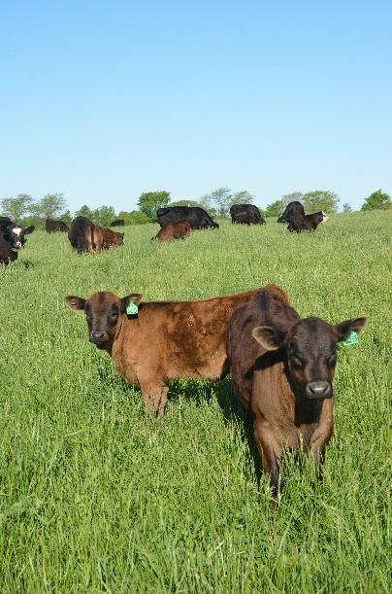
“Grazing is such an integral part of cattle production — from cow-calf to stockers,” Clark said. “Whether due to too little or too much moisture, our grazing lands have taken a beating. They need recovery. And that takes time.”

Clark recommends producers extend a gentle hand of management through 2023. Record herd liquidation during recent years presents an opportunity to reduce grazing pressure or extend rest periods.

“Before producers consider buying or renting more hard-to-find pastureland, we recommend taking action to improve the grazing acres they already have,” he said. “That approach can help enhance profit potential.”

Clark suggests producers consider these four steps during 2023:

- Manage moisture for maximum benefit. To help speed drought recovery, control low-value, undesirable plants — including viny blackberry/dewberry and opportunistic volunteer trees — ensuring moisture goes toward grass recovery, rather than to growing weeds. In rain-saturated areas, weeds will aggressively outcompete forage grasses. For broadleaf weeds, a residual herbicide, such as DuraCor® herbicide, will help control biennial thistles and other weeds early, along with later-emerging species, like ragweed.
- Add flexibility in grazing management. Crossfencing to split a larger pasture into two smaller pastures allows producers to switch paddocks based on the level of production and the amount of rest needed for the previously grazed pasture to recover. This can help improve forage utilization and allow for greater rest-recovery periods.
- Consider cultural practices to boost productivity. Incorporating weed and brush control, fertilizing according to soil test or overseeding where needed can help restore productivity. In states where offered, UltiGraz℠ Pasture Weed & Feed saves an application cost by combining herbicide and fertilizer in a single pass.
- Focus on becoming a low-cost producer. Remember: Grazed forages represent the cattle producer’s lowest-cost feed source. Investing in pasture improvement is an excellent cost-management strategy. Don’t overlook opportunities to prebook fertilizer, herbicides, feed, hay and other inputs when pricing is favorable, as well.

“Herd rebuilding or expansion must start with enabling grazing land to support the additional animals over the long term,” Clark said. “Your trusted advisers, such as Extension specialists, consultants or industry experts — including those from Corteva Agriscience — can help you make the best decisions for your operation.”

Learn more about how intensifying pasture management can provide the vital foundation for herd expansion at RangeAndPasture.com/ROI. Find your Corteva Range & Pasture Specialist at RangeAndPasture.com.

-end-

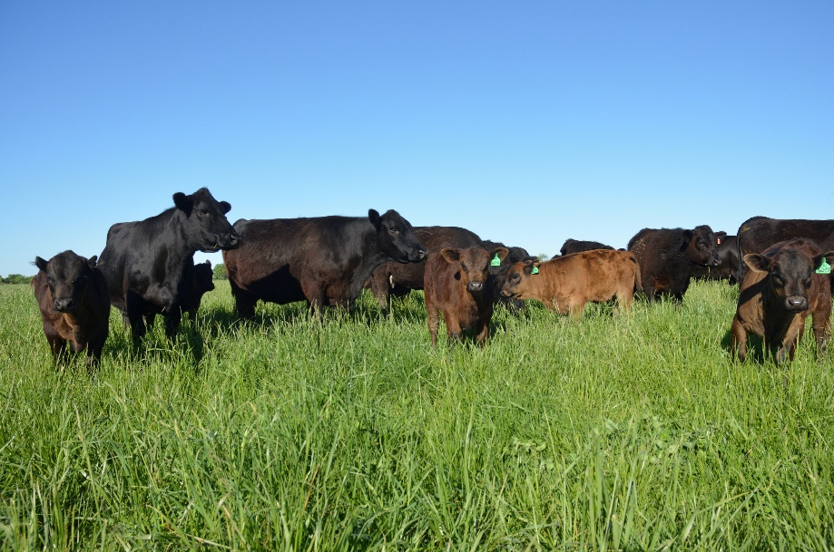

Improving pastures during the 2023 grazing season can empower forage recovery, providing the flexibility to capitalize on market opportunities.

Follow Range & Pasture at Corteva Agriscience at RangeAndPasture.com and on Facebook, Instagram and Twitter.

About Corteva Agriscience
Corteva, Inc. (NYSE: CTVA) is a publicly traded, global pure-play agriculture company that combines industry-leading innovation, high-touch customer engagement and operational execution to profitably deliver solutions for the world’s most pressing agriculture challenges. Corteva generates advantaged market preference through its unique distribution strategy, together with its balanced and globally diverse mix of seed, crop protection, and digital products and services. With some of the most recognized brands in agriculture and a technology pipeline well positioned to drive growth, the company is committed to maximizing productivity for farmers, while working with stakeholders throughout the food system as it fulfills its promise to enrich the lives of those who produce and those who consume, ensuring progress for generations to come. More information can be found at www.corteva.com.

Follow Corteva on Facebook, Instagram, LinkedIn, Twitter, and YouTube.

# # #
02/28/23

™ ® ℠ Trademarks and service marks of Corteva Agriscience and its affiliated companies. Under normal field conditions, DuraCor® is nonvolatile. DuraCor has no grazing or haying restrictions for any class of livestock, including lactating dairy cows, horses (including lactating mares) and meat animals prior to slaughter. Label precautions apply to forage treated with DuraCor and to manure and urine from animals that have consumed treated forage. DuraCor is not registered for sale or use in all states. Consult the label for full details. UltiGraz℠ with fertilizer is available for use with specific herbicides in the states of AL, AR, CO, FL, GA, HI, IA, ID, KS, KY, LA, MN, MO, MS, MT, NC, ND, NE, NV, OK, OR, SC, SD, TN, TX, UT, VA, WA, WI, WV and WY. Contact your state pesticide regulatory agency to determine if a product is registered for sale or use in your area. Always read and follow label directions.

Contacts
Larissa Capriotti
515-805-4854
larissa.capriotti@corteva.com

Erik Johnson
Bader Rutter
262-993-9837
ejohnson@bader-rutter.com

