Tennessee seedstock operation boosts profits with ultimate grazing

Deer Valley Farm, a registered Angus seedstock operation a little more than an hour south of Nashville, Tennessee, is primarily a forage-based operation. Its cattle live year-round on forages produced on the farm.

“Our forage program is extremely important to us,” says Jonathan “JP” Perry, longtime manager of Deer Valley Farm. “To manage 2,000 head annually on bought feed is not feasible at all. So we take care of the forages and land year-round and grow products we can utilize within our feed systems here on the farm.”

Perry says middle Tennessee is “feast or famine.” They receive a lot of rain, but it takes a lot to keep fescue and orchardgrass viable, particularly through hot, dry summer months. They closely monitor the stocking rate and pasture rotation year-round. Perry says their goal is to leave enough grass on the ground to sustain the herd until fall, when the fescue and orchardgrass flourish, taking them into winter.

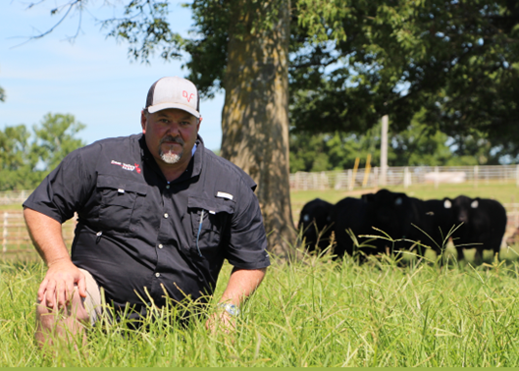
“We believe in taking care of the land that supports us,” Perry says. “If we don’t, it’s not going to give back. Everything we do from a forage standpoint is intended to make the ground more productive, to make it work for us, to create some sustainability,” he says.

Perry prefers to apply fertilizer and weed control early to give the forages a head start. This not only provides grasses an early season push to get up and growing but also holds down weeds well into the grazing season. Recently, Deer Valley Farm began using UltiGraz℠ Pasture Weed & Feed — whether with DuraCor® or GrazonNext® HL herbicide — to deliver weed control and fertilizer in a single pass.

“UltiGraz does a tremendous job providing early weed control, giving the grass the chance to compete,” Perry says. “And it does a very good job of controlling weeds throughout the spring and summer as grasses come on and reach maturity.”

Originally, Deer Valley Farm tank-mixed liquid nitrogen with its weed control herbicides, which worked great except the farm team couldn’t put out everything needed in one pass. Consequently, several key elements their soils needed were left out. Perry says UltiGraz works better for them because they can custom-blend the dry fertilizer according to soil test. They then add the appropriate weed control herbicide, whether DuraCor or GrazonNext HL, and make one pass across the farm.

“It works better for us,” Perry says. “Everything is there on the ground to do what we need in a timely manner. And applying everything in one trip makes a huge economic impact. Otherwise, we have to go through and fertilize with dry mix and come back to spray weed control on the ground,” he says.

Perry explains they used to apply liquid fertilizer and herbicide separately. They’d often get the fertilizer out early, intending to come back with weed control. But then it would rain or they’d get busy and never get back across the whole place.

“You get in a hurry, and you say, ‘Well, I'm just going to put nitrogen out now, and then I'll come back.’ You don’t get back. That happened every single year before we switched to UltiGraz,” he says. “We were the victim of our own game.”

The philosophy at Deer Valley Farm ensures the cattle get the forage and gains they need. Momma cows are healthy, get bred back quickly and are nursing calves — doing the things they’re meant to do.

“When the grass is managed right and the weeds are controlled, we have a better grass mat. We have less erosion,” Perry adds. “The cattle and the land work better. It’s much more sustainable.”

-end-

Photo Caption:

Jonathan Perry, Deer Valley Farm manager, says everything they do from a forage standpoint is intended to make the ground more productive.

Contact:
Amanda B. Powell
Bader Rutter
770-356-1480
apowell@bader-rutter.com

™ ® ℠ Trademarks and service marks of Corteva Agriscience and its affiliated companies. Under normal field conditions, DuraCor® is nonvolatile. DuraCor and GrazonNext® HL have no grazing or haying restrictions for any class of livestock, including lactating dairy cows, horses (including lactating mares) and meat animals prior to slaughter. Label precautions apply to forage treated with DuraCor or GrazonNext HL and to manure and urine from animals that have consumed treated forage. DuraCor and GrazonNext HL are not registered for sale or use in all states. Consult the label for full details. UltiGraz℠ with fertilizer is available for use with specific herbicides in the states of AL, AR, FL, GA, IA, KS, KY, LA, MO, MS, NC, ND, NE, OK, OR, SC, SD, TN, TX, VA, WA and WV. Contact your state pesticide regulatory agency to determine if a product is registered for sale or use in your state. Always read and follow label directions.

