3 Ways to Make the Most of Winter Moisture

Winter precipitation has helped improve drought conditions in many areas. Although temptations will be high to save on hay-feeding costs and get cows back doing what they do best, allowing cattle to graze too soon this spring likely will do more harm than good.

“Producers who receive moisture after drought will want to think through long-term recovery plans before turning cattle out,” says Will Hatler, field scientist, Corteva Agriscience. “It’s important to consider practices that will boost forage growth and maximize available moisture and soil nutrients.”

Hatler shares three tips to make the most of moisture this spring.

1. Delay grazing to preserve roots. Any moisture will help cool-season grasses take off, but resist the temptation to turn cattle out too quickly. Following a drought, plants that appear healthy likely still have a shallow root system. Grazing these pastures too early will inhibit root reserves from reestablishing — ultimately leading to weaker, thinner plant stands.

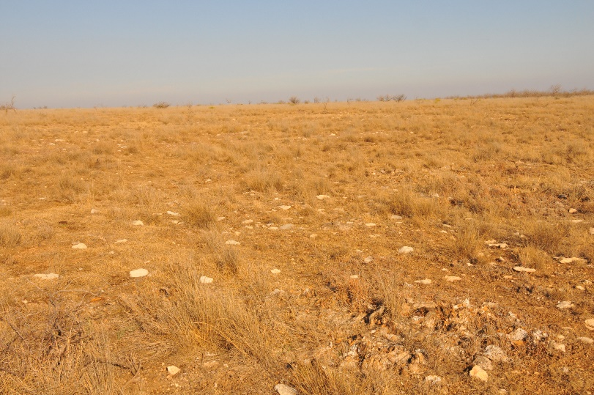
“Feeding hay while allowing the roots to reestablish and rebuild may cost more today, but it will pay off in the long run,” Hatler says. “Depleting the root reserves through grazing can result in a need to reseed the pasture at some point down the road, which is very costly.”

He recommends carrying a yardstick when you’re out checking pastures to measure grass stands. A best practice is to wait until the cool-season grasses are at least 4 inches tall before allowing cattle to graze the pasture.

2. Watch for weeds. Like grass, weeds love moisture. Keep an eye on bare space out in the grass, as weeds will likely grow there first.

“It’s important to limit any competitive plants that aren’t providing any forage value,” Hatler explains. “Scout early and treat early to prevent weeds from stealing the much-needed moisture.”

3. Monitor hay-feeding sites. Weeds often ride along with purchased hay, so you’ll want to keep an eye out for new weed infestations in areas where outside hay was fed. Determine which species of weeds are present and ensure you’re selecting effective herbicide treatments.

“I always encourage producers to get out into their pastures,” Hatler says. “Sometimes if we just drive past a weed and don’t stop to examine it, we might misidentify it. This is especially true with invasive species that have found their way into new territories.”

No matter the amount of moisture your operation has (or has not) received, Hatler’s best piece of advice is to think long term and protect root reserves at all costs.

“The drought has forced many producers to make extremely difficult decisions, but we must have grass to have a sustainable beef operation. Those difficult decisions today will pay off when moisture returns.”

-end-

Photo Caption:

Drought-stressed forage grasses require time — and moisture — to recover. Scout early and control broadleaf weeds to help ensure any available moisture goes toward growing grass, rather than to growing weeds.

Contact:
Erik Johnson
Bader Rutter
262-993-9837
ejohnson@bader-rutter.com

